attractions. I shall place my delight in the remembrance of Your favors, Your love and Your mercy to me.
I consecrate to You my body. Purify it more and more and make it worthy of being the temple of the Holy Spirit. I now surrender it to You; dispose of it according to Your blessed will. I will submit freely to all mortifications, infirmities, sickness, sorrows and death. I desire nothing but what You desire; and however painful the cross may be which You have prepared, I await, through Your grace, with entire submission, happy in being able to say with the great apostle: With Christ I am nailed to the cross.
I consecrate to You, sweet Jesus, all that I might ever possess in earthly goods, authority or influence. All is Yours; dispose of me as You please. I consecrate to You all that I can: joys, sorrows, life and death to testify to You my love and to induce all hearts to love You.
I now resolve, with the help of Your grace, O my God, to be Yours without reserve or division, and to serve You with lively devotion to the last hour of my existence.

Preparatory Novena for
the Jubilee Year 2023-2024
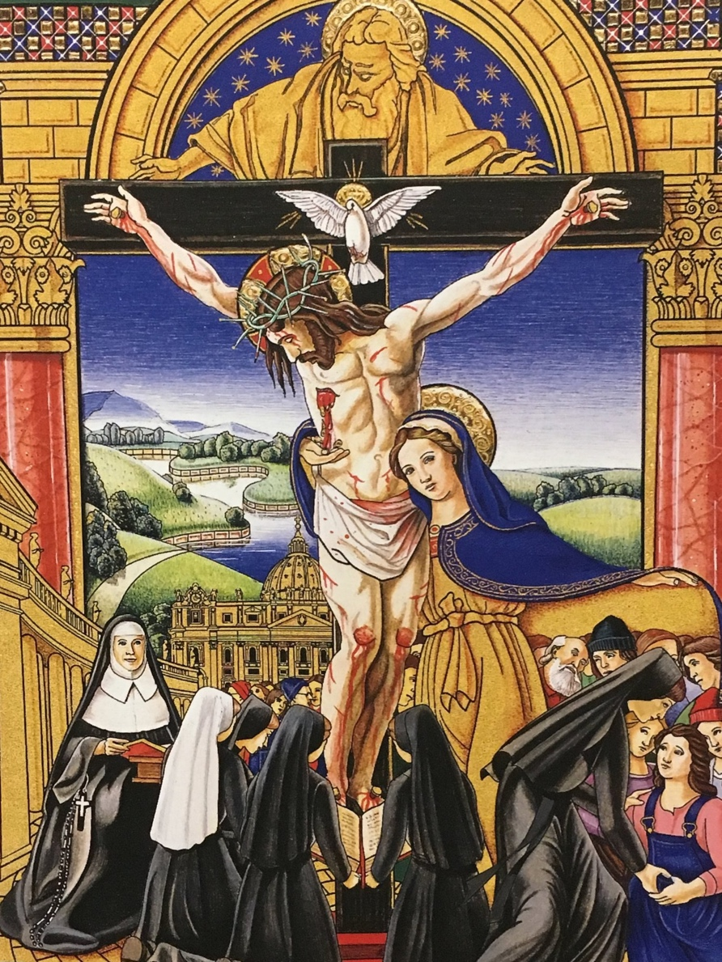

Intentions for the Novena:

To be prayed on the first of each month, after meditation and before the Holy Sacrifice of the Mass.

January 1st: that we may be increasingly disposed to receive the virtue of faith

February 1st: that we may be increasingly disposed to receive the virtue of hope

March 1st: that we may be increasingly disposed to receive the virtue of charity

April 1st: for a receptive openness to the virtue of prudence

May 1st: for a receptive openness to the virtue of temperance

June 1st: for a receptive openness to the virtue of fortitude

July 1st: for a receptive openness to the virtue of justice

August 1st: for a deepening of the corporal works of mercy

September 1st: for a deepening of the spiritual works of mercy

Prayer of Consecration of
Venerable Mother Catherine:

Act of Consecration of Venerable Catherine McAuley
O God of my heart, my whole desire consists in loving you. To you I devote myself without reserve and forever. I consecrate to You my heart; receive it as an acceptable sacrifice. I confide it to You to preserve and unite it with Yours; for with You I desire to reside all the days of my life; to live in the future unknown to the world and known only to You.
To You I consecrate my will, that it may be conformable to Yours in all things. O dear Jesus, may Your will be done in me. You are my Lord and Savior, my God. Behold me now entirely at Your disposal.
I consecrate to You my understanding; I shall no longer judge of anything but according to Your divine light. May Your grace work in me the accomplishment of the holy desire with which it now inspires me.
I consecrate my memory to You. It shall always remind me of Your infinite perfections, Your goodness, Your sublime

